Feb 3, 2022

Client Report

Pai Liu

For helping you review our project, the picture below are our system diagrams.

System diagram:

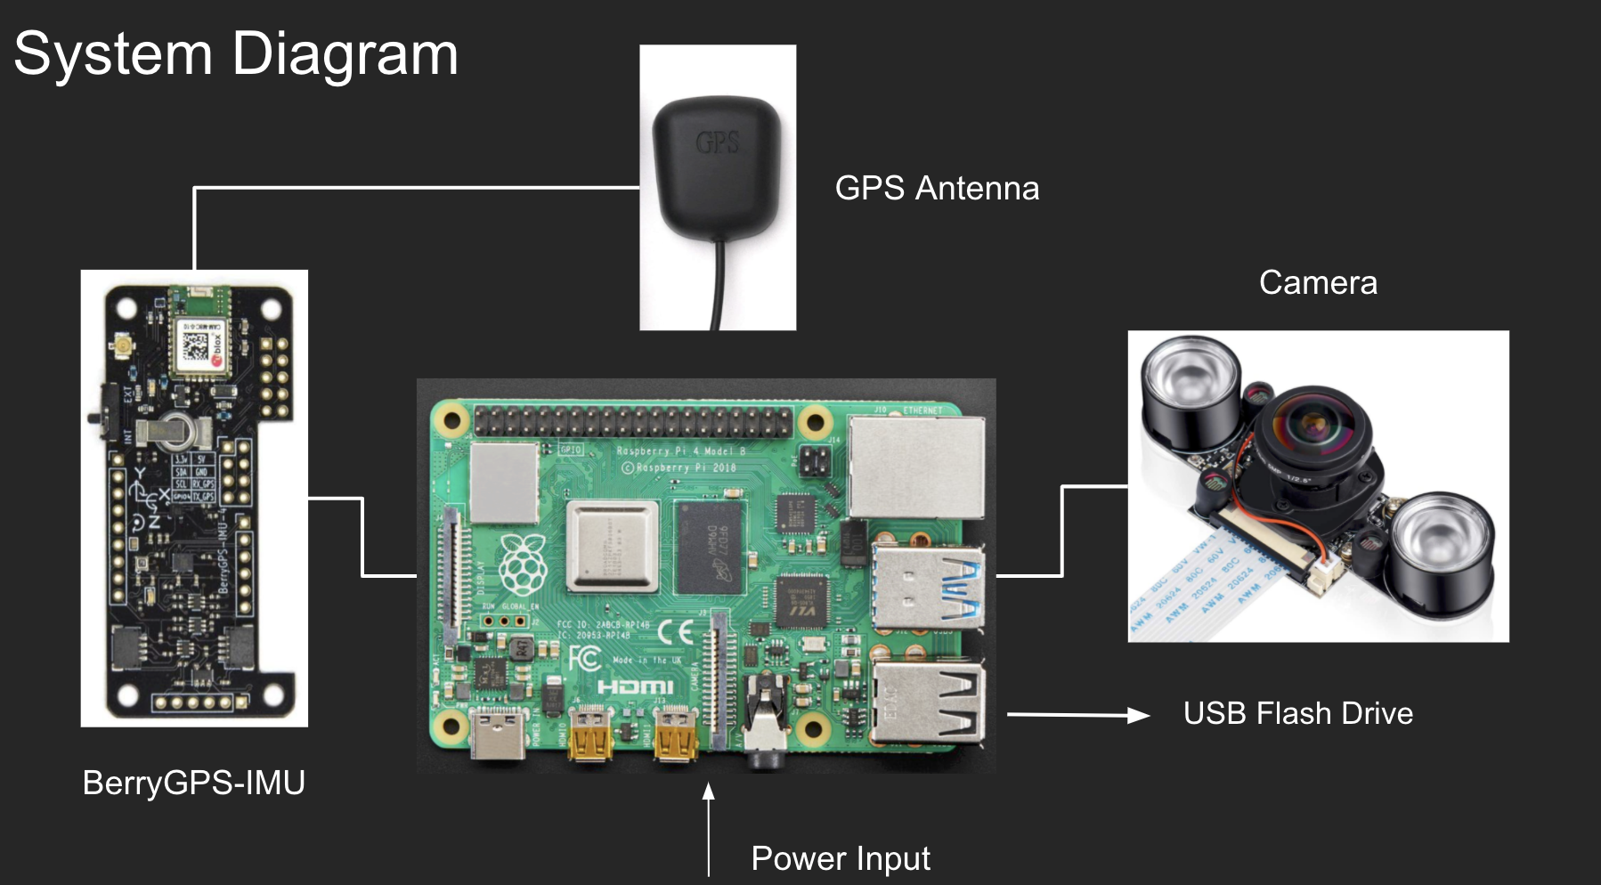

Hardware diagram:

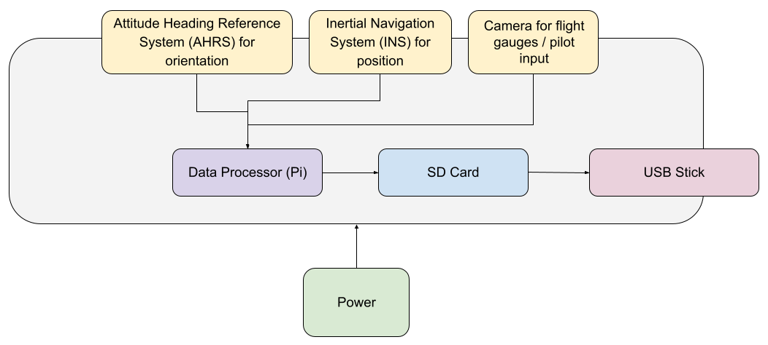

Software Diagram:

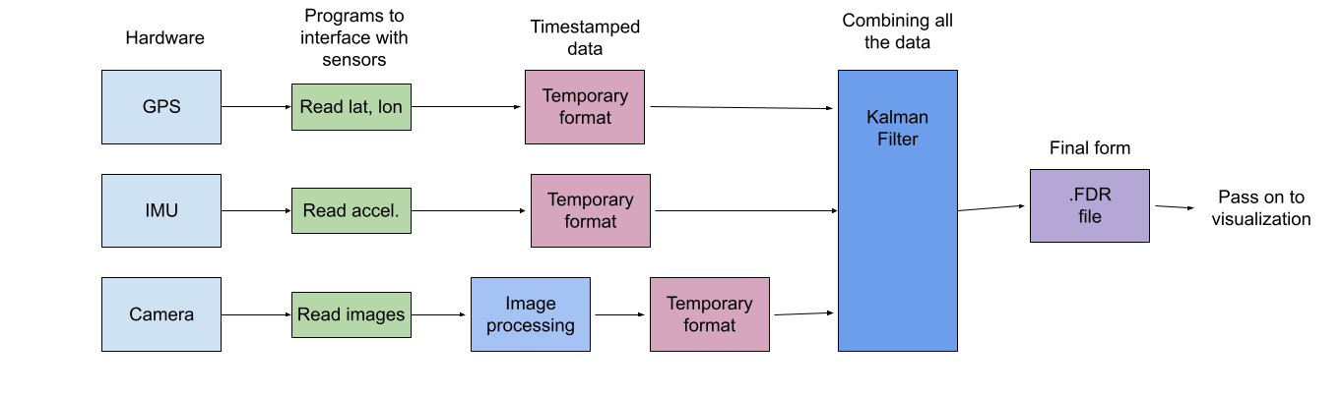

Completely task:

First Prototype

* Camera
* IMU
* Pressure Sensor
* GPS\*
* Converting sensor data to .fdr file
* X-Plane 11 replay

All the hardware and software component in the list above are tested last semester, However, we are having unstable GPS connecttion issue, the current solution is changing GPS module, the part is arrived, and we are currently working on installation.

Upcoming task:

1. Install new GPS module and testing (02/04)
2. Image processing testing (02/15)
3. Frequence synchronized (02/22)
4. in-air testing(TBD)

Here are our due dates of up coming task, we are still working on image processing, and frequence synchronization.